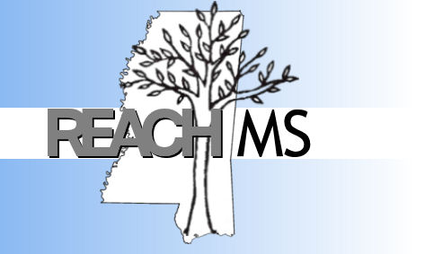
REACH MS
Mississippi’s State Personnel Development Grant
University of Southern Mississippi Phone: 601.266.4693
118 College Drive #5057 Fax: 601-266-4691
Hattiesburg, MS 39406 Email: reachms.org

Realizing Excellence for ALL Children in Mississippi

April 13, 2020

Dear Model Site,
We are excited that your classroom is a REACH MS Universal Design for Learning (UDL) Model Site. We are very impressed with all of the accessible systems and supports provided to all students in your classroom.
With all of the success and growth of the UDL initiative recently, REACH MS staff wanted to make certain your team was clear on the expectations of all Model Site Classrooms. First, the class universal screener data for the Fall/Spring must be submitted to REACH MS at least each semester. This data must be submitted within a timely manner (prior to leaving for Christmas/Summer break) to maintain Model Site status. Second, all Model Site Classrooms are required to be re-evaluated for fidelity of implementation data annually. This data includes the Implementation Fidelity Tool and the Classroom Site Evaluation Tool (C-SET). Twenty percent of the Model Site Classrooms are selected for re-evaluation utilizing the C-SET annually. If your classroom is selected, you will be notified by REACH MS staff. Lastly, all model site classrooms must agree to host model site visits by other sites interested in implementing UDL and agree to complete and submit the necessary paperwork and comply with the eligibility requirements in order to receive the incentive amount listed in the agreement. These visits allow fellow educators to see UDL in action and are a vital part of the continuation of this initiative in Mississippi schools.
We look forward to our continued work together in improving outcomes for all students in Mississippi.
Thank you and please let us know if you have any questions.

REACH MS 2019 - 2020 UDL Model Site Agreement
In signing this form, I acknowledge that:
- My class will submit Fall/Spring universal screener data to REACH MS staff.
  - Universal Screener data will be submitted by email to REACH MS staff.
  - This data must be submitted within a timely manner (prior to break) to maintain Model Site status.
  - Model Site status may be removed if universal screener data is not submitted PRIOR to Christmas/Summer break during the school year.
- My class will submit to being re-evaluated for fidelity of implementation data annually.
  - This data includes the Implementation Fidelity Tool and/or the Classroom Site Evaluation Tool (C-SET).
  - Failure to submit to re-evaluation by way of the annual Implementation Fidelity Tool may result in removal of Model Site status.
  - Twenty percent of the Model Sites are selected for re-evaluation utilizing the C-SET annually.
  - Schools selected for a re-evaluation may choose not to complete the evaluation and will not continue as a REACH MS Model Site.
- My class will submit required paperwork and comply with all eligibility requirements involved in hosting model site visits by other sites interested in implementing UDL.
  - Classroom/School will receive a $100.00 incentive for hosting other schools/district UDL Teams (team is defined as three or more people).
  - To receive the incentive, the hosting school must complete a REACH MS Model Site Visit Form and return it to the REACH MS office.
  - Visiting schools will receive $200.00 to supplement travel cost. The visiting school team (team is defined as three or more people) must complete a Model Site Visit Evaluation Form. The hosting school will return the forms to REACH MS.
We have read the information regarding the expectations of REACH MS UDL Model Sites. My classroom/school is committed to fully participate in these expected activities as listed above.
__________________________________ _____________________________
Administrator Signature Date

Model Sites Classrooms are provided the following recognitions:
· A monetary award to support the classroom UDL efforts and activities.
· A UDL Model Implementer pin given to each staff member.
· A framed certificate displayed in the classroom.
· Listed as a UDL Classroom Model Site on the REACH MS website.
· Eligibility to host Model Site visits by other sites interested in implementing UDL.
· Public acknowledgement on REACH MS Facebook page.

Schools will receive a $500.00 incentive for attaining a Model Site status.
- Classroom/School will receive a $100.00 incentive for hosting other schools/district UDL Teams (team is defined as three or more people).
- To receive the incentive, the hosting school must complete a REACH MS Model Site Visit Form and return it to the REACH MS office.
- Visiting schools will receive $200.00 to supplement travel cost. The visiting school team (team is defined as three or more people) must complete a Model Site Visit Evaluation Form. The hosting school will return the forms to REACH MS.

Incentives may not exceed REACH MS’s annual budgeted amount.

